Bureaucracy: Thursday, 4-9-2020

The Bureaucracy
- Bureaucracies: large administrative agencies that have a hierarchical authority structure, job specialization, and rules and regulations that drive them. (SEE Diagram Below). The bureaucracy of the U.S. Government is basically split up into two major parts: the cabinet departments and the “A.B.C.” agencies. The bureaucracy is part of the executive branch and as such has as its main function to help the president enforce statutes by Congress.

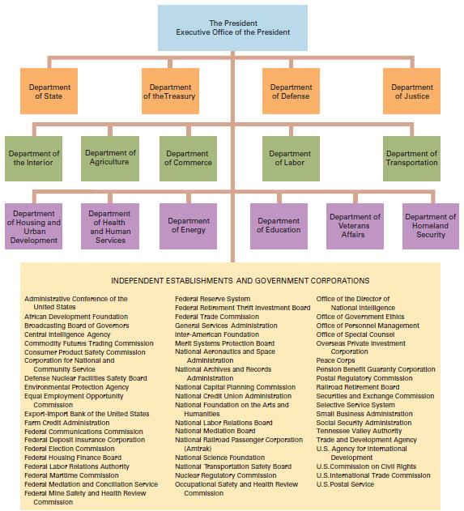
- The U.S. Government bureaucracy is INTEGRAL to the organization and operation of the federal government. Not only do agencies, cabinet departments, etc. implement governmental policy made by Congressional statutes, but they also make policy when they issue regulations. Legislation by Congress is often written in general terms that need many “gaps” to be filled in by the bureaucratic agencies, because the bureaucratic agencies are staffed by thousands of people who are experts and work in the agencies for their whole career (we call these people the “rank and file” workers that are hired, not elected, and often serve in the agencies their whole careers).

- There are 3 types of governmental bureaucratic agencies in the Executive Branch:

- cabinet departments: 15 Departments, each headed by a secretary, except the Department of Justice, which is headed by the Attorney General. Secretaries are appointed by the president and confirmed by the Senate. (e.g.: Departments of Treasury, State, Homeland Security, Health and Human Services, Commerce, Agriculture, Defense, Education, Energy, Housing and Urban Development, Interior, Justice, Labor, Transportation, and Veteran’s Affairs)

- regulatory agencies (alphabet agencies): regulatory agencies are known as “independent regulatory agencies” because they are “quasi-legislative” (they act like a legislature when they issue regulations) AND “quasi-judicial” because they act in a manner that is judicial when they enforce penalties(usually fines) for violations of their regulations. Prominent agencies are: Interstate Commerce Commission (ICC), Federal Trade Commission (FTC), Food and Drug Administration (FDA), Securities and Exchange Commission (SEC), Environmental Protection Agency (EPA), Occupational Health and Safety Administration (OSHA), and the Federal Election Commission (FEC)
***IMPORTANT: bureaucratic departments and agencies have what is known as bureaucratic discretion , A.K.A. “delegated discretionary authority”(i.e. they can decide what regulations to make to enforce Congressional statutes AND how much to enforce those rules and regulations).
***ALSO, bureaucratic rules and regulations have the force of law, SO they are subject to judicial review.
- government corporations: These are hybrid organizations that are a cross between a private business corporation and a government agency. These government corporations were designed to make a profit to support themselves; however, they usually do not and must ask Congress for subsidies (money) to keep themselves from having to declare bankruptcy! Examples: Tennessee Valley Authority (TVA); Amtrak; U.S. Postal Service.
- The U.S. bureaucracy has decreased in size (overall) in the last decade or so.
- CONGRESSIONAL POWER OVER THE BUREAUCRACY IS GREATER THAN THAT OF THE PRESIDENT…SEE THE CHECKS BELOW:

-Although independent in nature, bureaucratic agencies in the federal government are linked to the president by appointment and to Congress through its oversight function.
-Congress can conduct oversight hearings in its committees by calling agency heads to testify about problems related to their agencies; Congress can restrict appropriations ($$$) to agencies (i.e. reduce their budgets because of Congress’ “power of the purse”).
-Senate approves heads of agencies and departments in the bureaucracy that are appointed by the president.
-Courts in the Judicial Branch will take appeals on decisions made by bureaucratic agencies
-president: bureaucratic agencies checked by appointment power of the president and by his executive orders. ALSO, the president can ensure with his authority over the bureaucratic departments and agencies that his political ideology is carried out. Prime examples are Trump’s EPA, which is loosening regulations on fossil-fuel companies and car manufacturers (fossil-fuel companies are being allowed to drill for oil in more places and power plants are not held to account with the number of and the stringency of pollution regulations as they were under Obama. Also, Trump just decreased the miles-per-gasllon that cars must meet…they were higher under the Obama administration).
-oversight functions of the OMB (Office of Management and Budget)
-pressure from interest groups, and political parties can modify bureaucratic behavior.
- the “Iron Triangle” (sometimes called “issue networks”): (see diagram below) a mutually dependent, mutually advantageous relationship interrelationship (some might say symbiotic) between the bureaucracy (an agency in the executive branch bureaucracy more precisely) , the Congress, and interest groups that lobby the agency.

Prime example: the tobacco iron triangle AND there are a plethora of others; just name a major industry!
Another prime example: the EPA; the heads of industrial factories that the EPA is regulating and the Congress that makes friendly legislation and oversight because of campaign contributions.

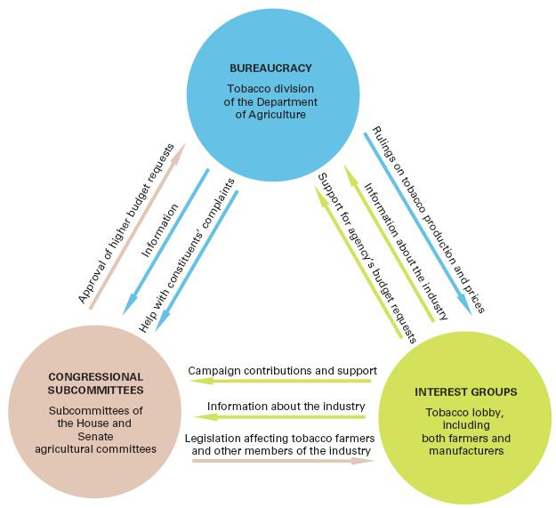

- EXAMPLES of HOW Influential Regulatory Agencies in the Bureaucracy are in Your Daily Life:

- food labeling by the Federal Trade Commission (FTC)
- meat inspection by the Food and Drug Administration (FDA)
- -airline safety by the National Transportation and Safety Board (NTSB)
- Seat belt mandates by the National Highway Traffic Safety Administration.

8) Pendleton Service Act: An act passed in 1883 that created a federal civil service so that hiring was based on merit rather than patronage.

- The Hatch Act: A federal law prohibiting government employees from active participation in partisan politics while on duty or from employees in sensitive positions at any time.
- Finally, because regulatory agencies invite so much controversy, there has been a recent trend toward deregulating the marketplace (i.e. removing government restrictions and regulations). Those in favor of deregulation claim that the competition of the marketplace is all the regulation that is needed. The deregulators say regulation is too expensive and time-consuming and involves too much necessary red tape.
Conservatives/Republicans favor deregulation. Liberals/Democrats prefer more regulation.

